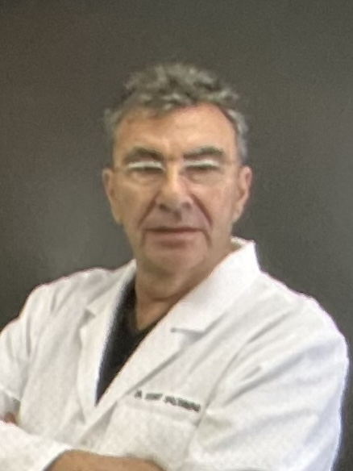
Stuart Shlosberg DDS, MSD
(424) 666 9093| Rancho Mirage, CA | got2th@gmail.com

PROFESSIONAL HIGHLIGHTS

Dentist with 25 years’ experience in general and prosthodontic dentistry.

General dental practice owner 10 + years in London, UK.
Post graduate in Prosthodontics, Indiana University
Full time dental faculty, Harvard University, Boston, Ma, and USC University, Calif.
15 years Private owner prosthodontic practice, Beverly Hills, Ca
Associate dentist, Palm Desert, Calif

PROFESSIONAL EXPERIENCE

Dental general practice owner/operator, London, UK 03/1972 – 08/1984

Harvard University School of Dentistry, Boston, Ma
Faculty Dept of Operative dentistry 01/1987 – 06/1989

University of Southern California
Sheets Dental Center. Faculty general dentistry 07/1989 - 09/1992

Private Practice - Prosthodontics – Beverly Hills, Ca 08/1996 – 11/2024
Owner/operator

Associate General Dentist – Aspen Dental, Palm Desert, CA 03/2025 - Current
Associate Dentist, Treatment diagnosis/ planning.
Dentures, implant fixed and removable.

EDUCATION
University of Indiana, Certificate in Prosthodontics 08/1984 – 11/1987
University of Indiana MSD: Dental Material Science 08/1984 - 12/1987
University of Manchester: School of Dentistry: Manchester, UK 09/1963- 01/1967
BDS (DDS)

